

13th March 2020

NEWSLETTER

Watton at Stone Primary and Nursery School
Newsletter 5th March 2021

Final messages about school reopening
We are very much looking forward to welcoming all of the children back to school on Monday and hope that they are also looking forward to returning to be with their friends and their teachers. I would like to take this opportunity to thank you all again for your hard work, support and commitment during these last few months to helping your children with their remote learning. I know that these have been extremely challenging times for everyone.

Before the children return on Monday, here are a few final reminders and requests.
Please ensure that all of the children return to school with their own equipment in a small pencil case. Children and staff shouldn’t be sharing equipment or stationery and so therefore it is important that children do have everything they require including a glue stick, rubber and pencil sharpner as these tend to be the resources that they don’t have in their pencil cases.
Teachers will be taking children outside to run the daily mile to support their emotional and physical wellbeing. We are aware that not all children have suitable school shoes for running in so we are happy for you to provide trainers in a carrier bag (should you wish to) which they will keep under their tables in class and change into them to run the daily mile. Please don’t send in ruck sacks as these take up too much space under the tables.
Please also ensure that all children come to school daily with a fresh bottle of water which will stay on their table with them.
Finally, a reminder that school will be compulsory from Monday 8th and all children are expected to return, registers will be taken and parents contacted if their child’s attendance is a concern.

School Priorities for the full reopening of the school

During the last few weeks, we have given lots of consideration to what the main priorities should be for when the children return until the end of the spring term and I’m sure that you will be pleased to hear that the children’s and staff’s wellbeing is the top of our priorities. Ensuring that the children are happy and settled, back in a secure routine and have time to talk to each other and re-establish friendships will all be extremely important. We are continuing with our Feel Good Friday’s until the end of term, providing additional break times, reinstating the daily mile and having 3 – 4 outdoor lessons across the curriculum a week as well as outdoor PE lessons as we know that movement breaks and brain breaks will support the children’s concentration and motivation during this period of resettling. Also on the plan is to ensure that we are reminding children of our behaviour and hygiene expectations, attendance and punctuality and informally assessing children to see who will need further intervention and support. For the core subjects our priorities will be phonics, reading, writing and maths.
We welcome you all to view the plans in more detail which have been saved to the website:
https://www.wattonatstone.herts.sch.uk/virtual-office/parent-forum

World Book day
This week, the whole school got involved in World Book day activities and celebrations. Children came to school and attended Zooms dressed in their pyjamas, a Tiger came to tea and there was a Mad Hatters Tea party,

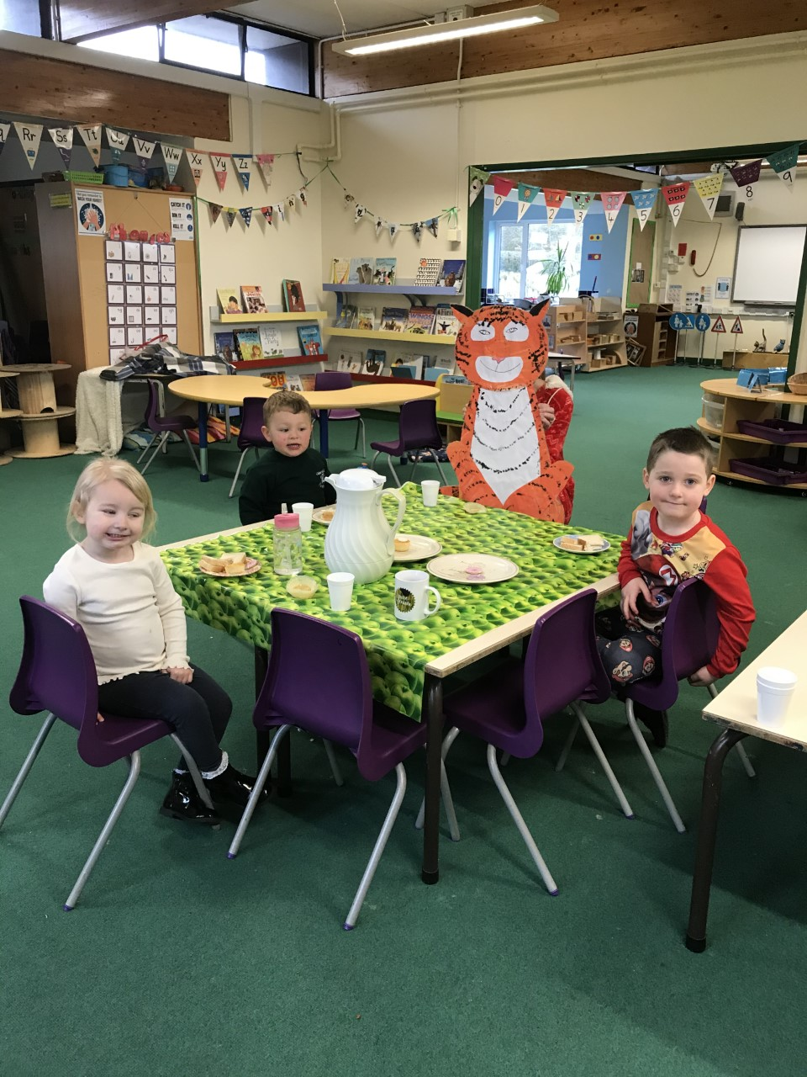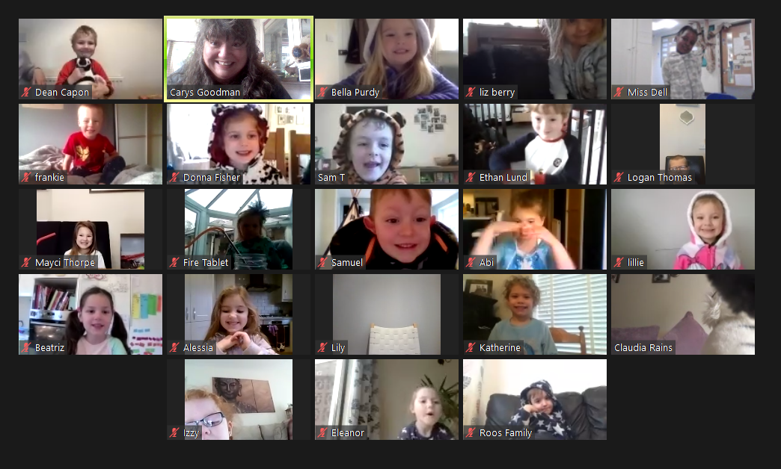

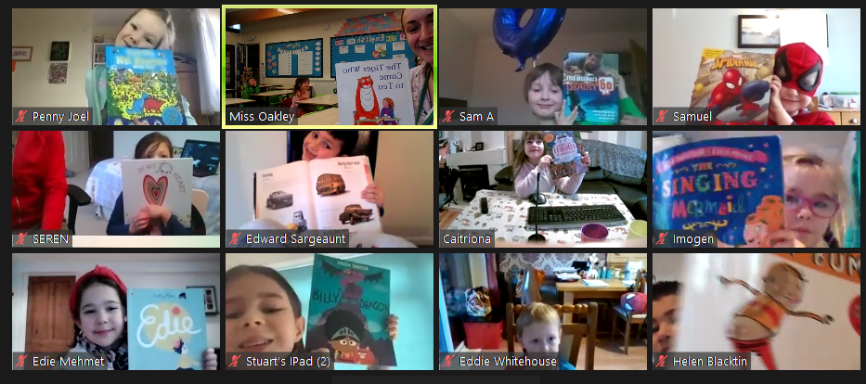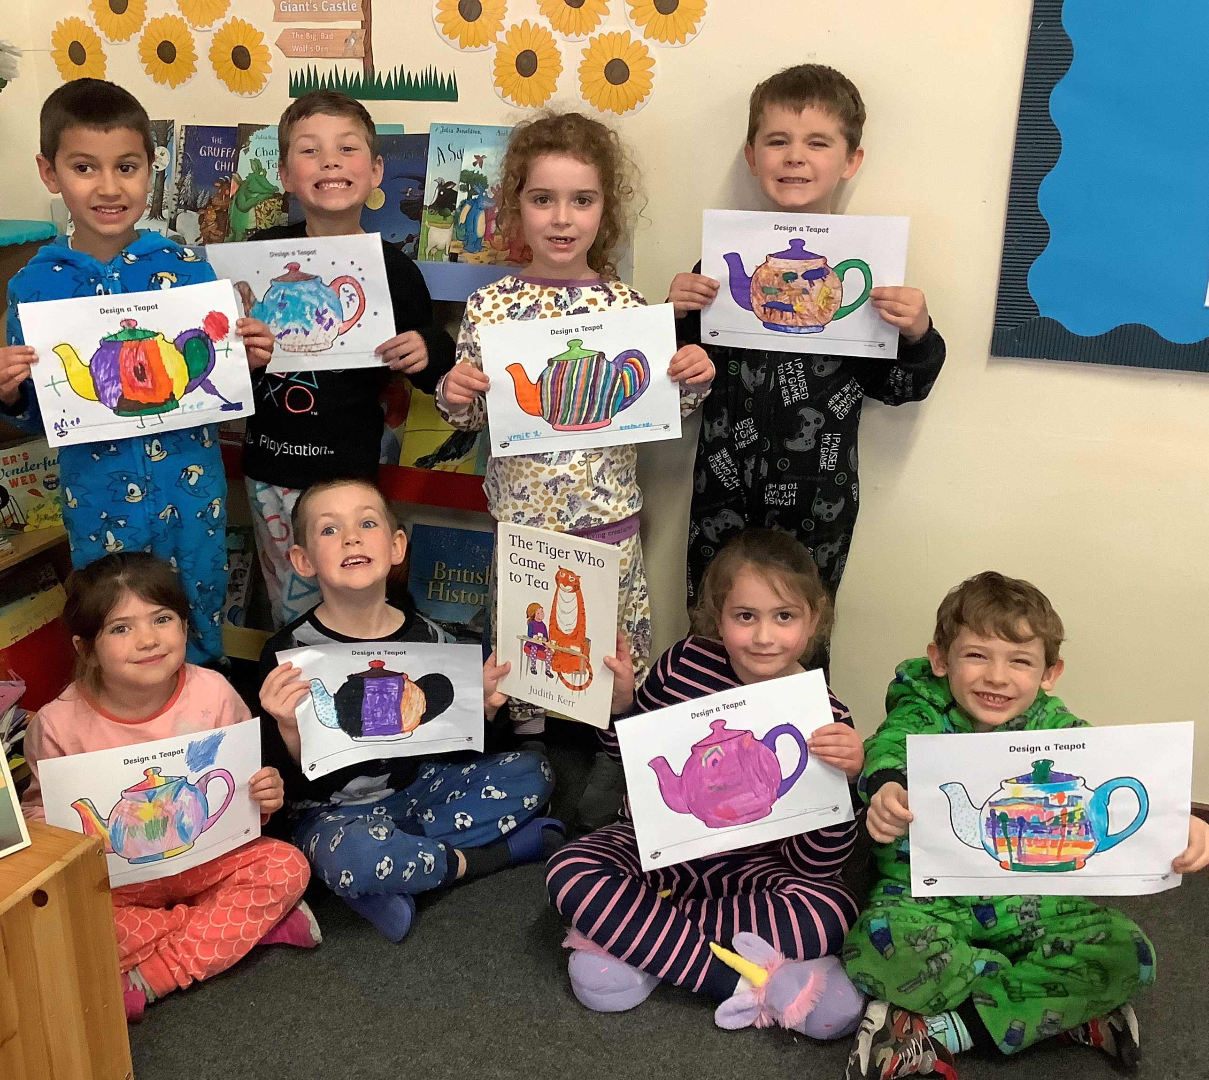

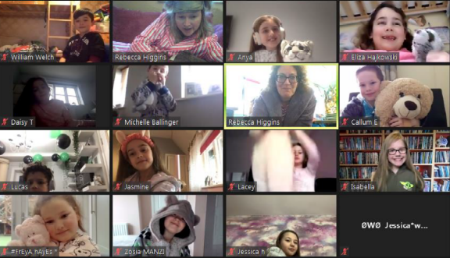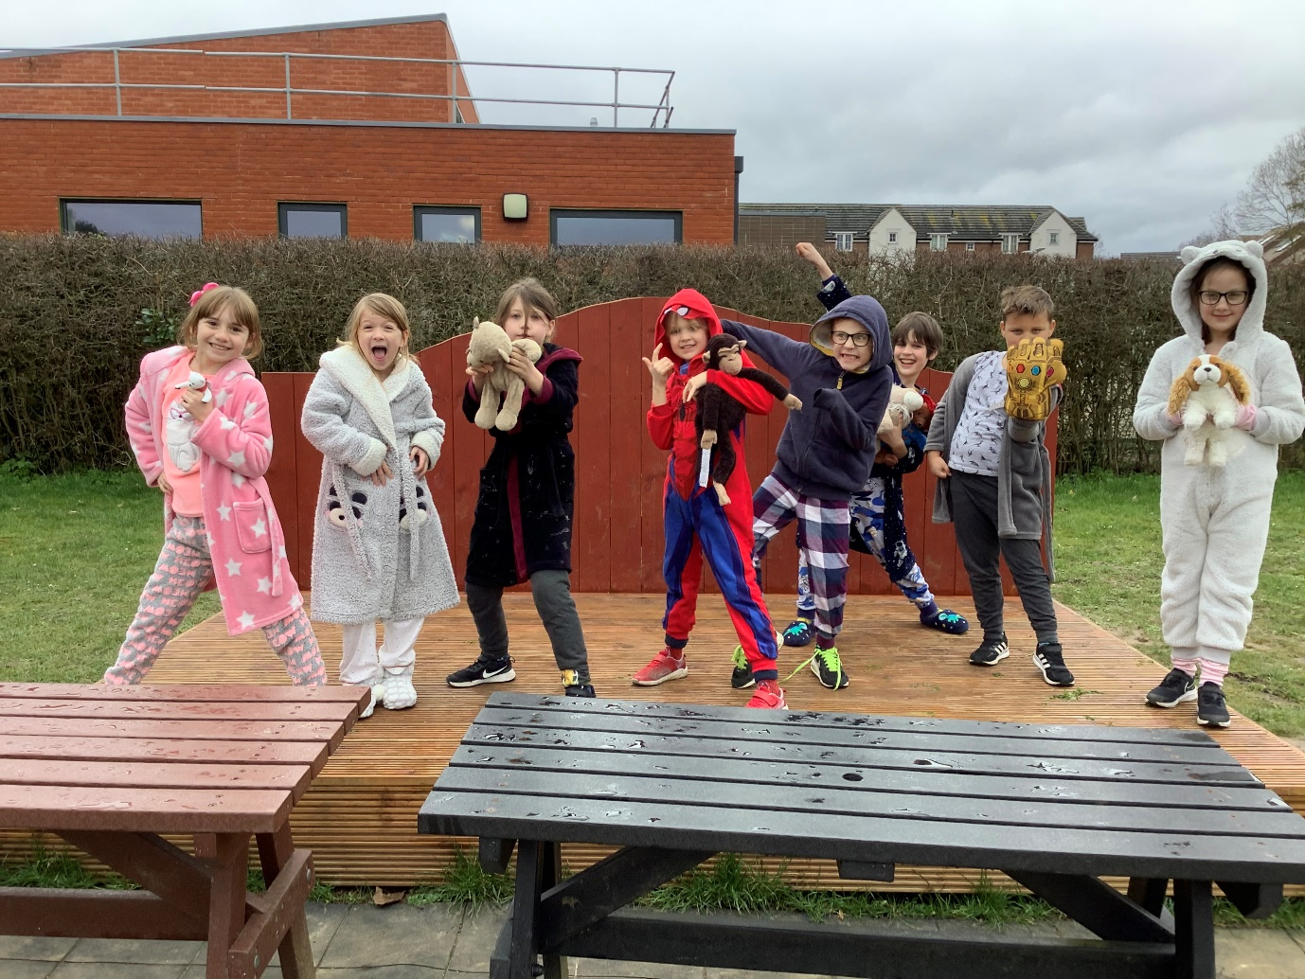

Year 1
Reception
Year 4

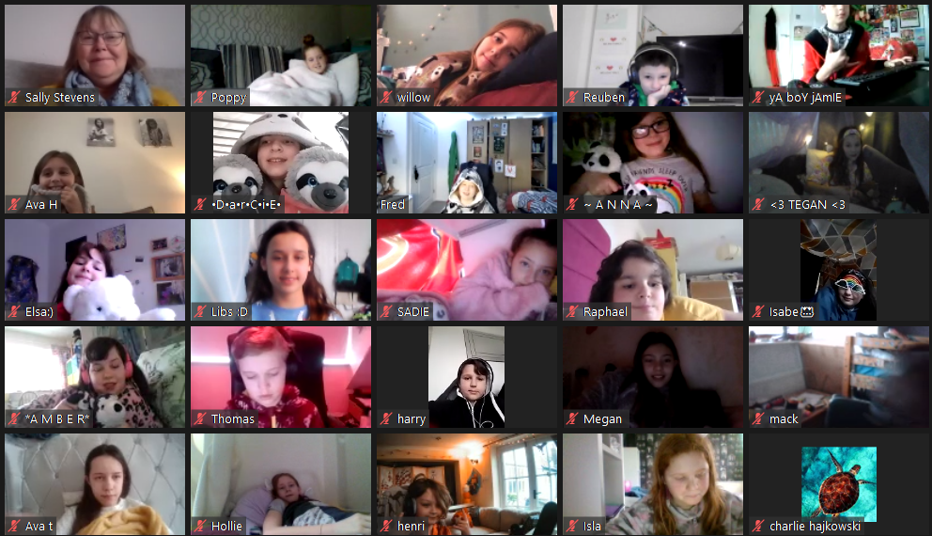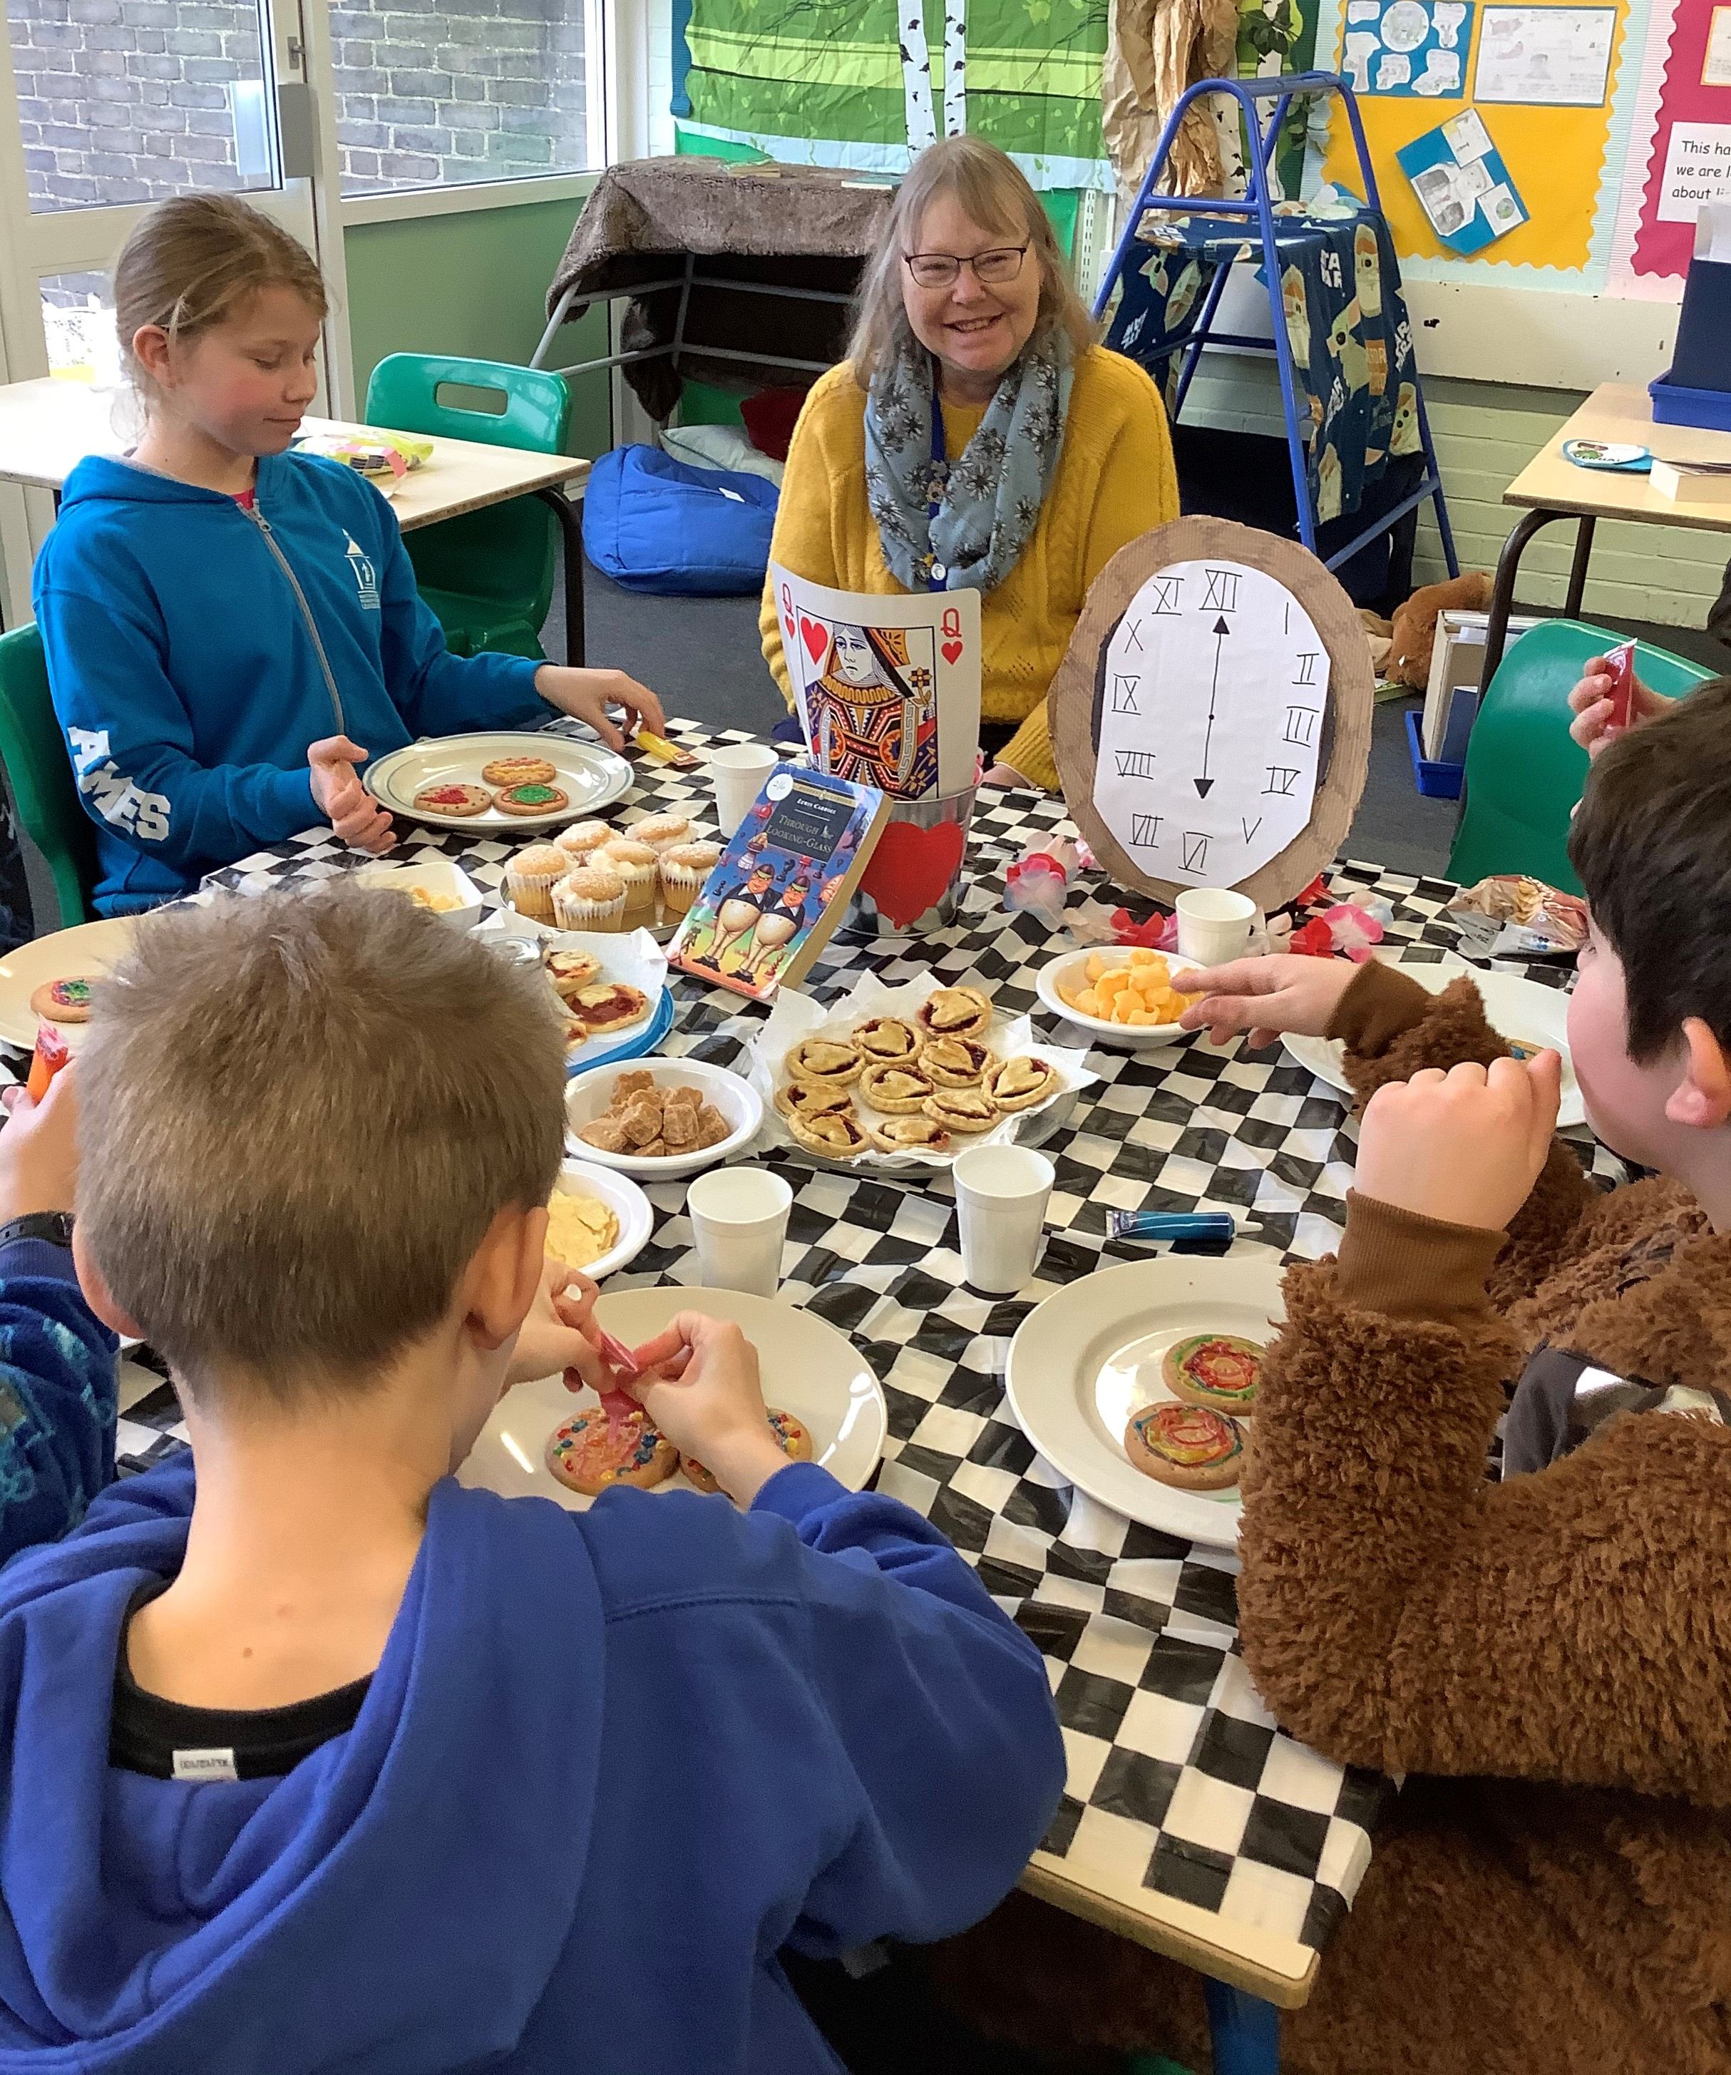

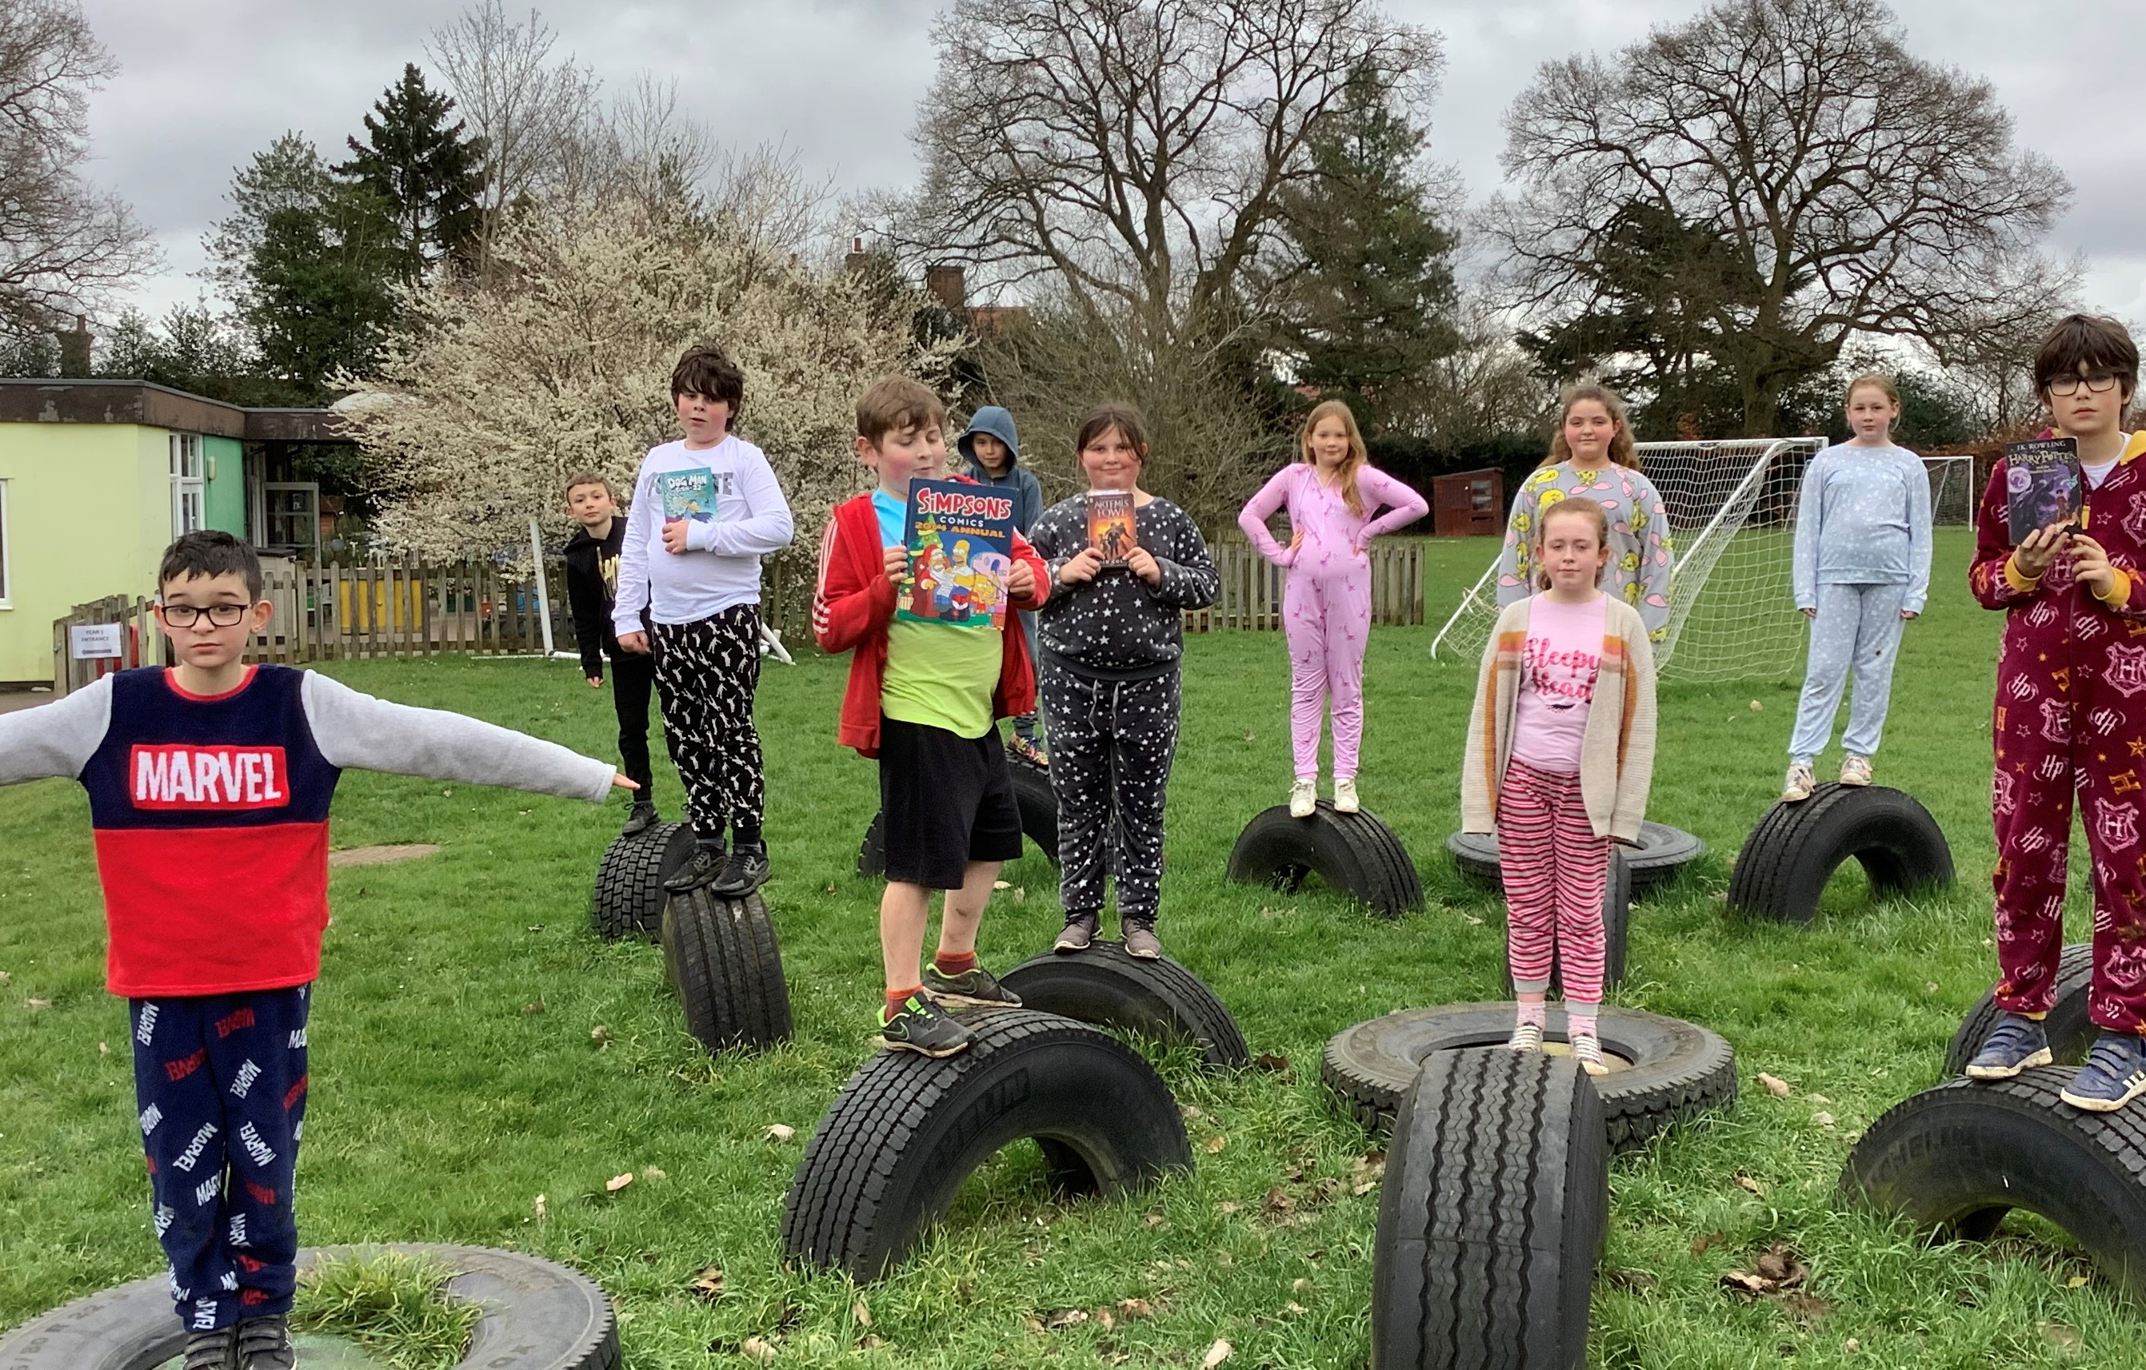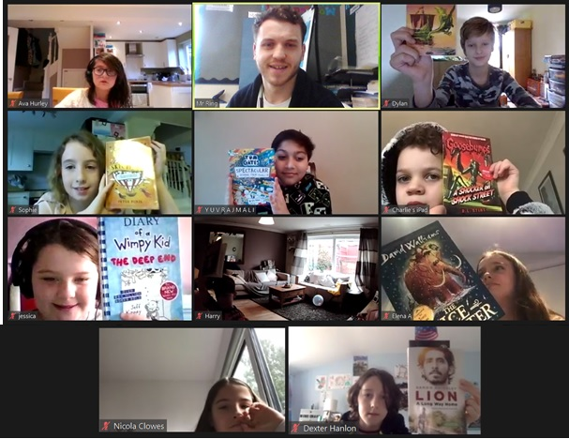

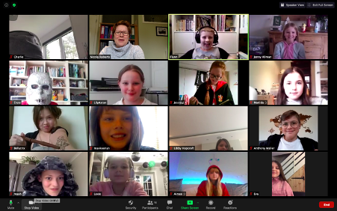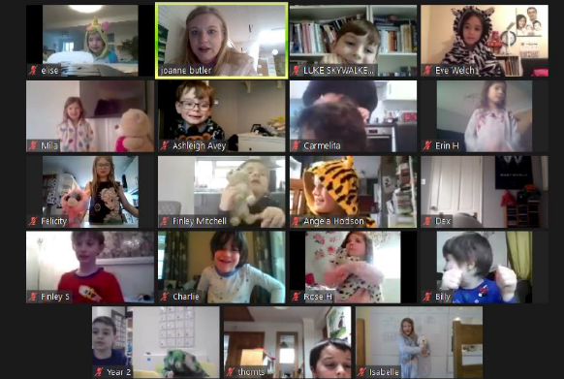


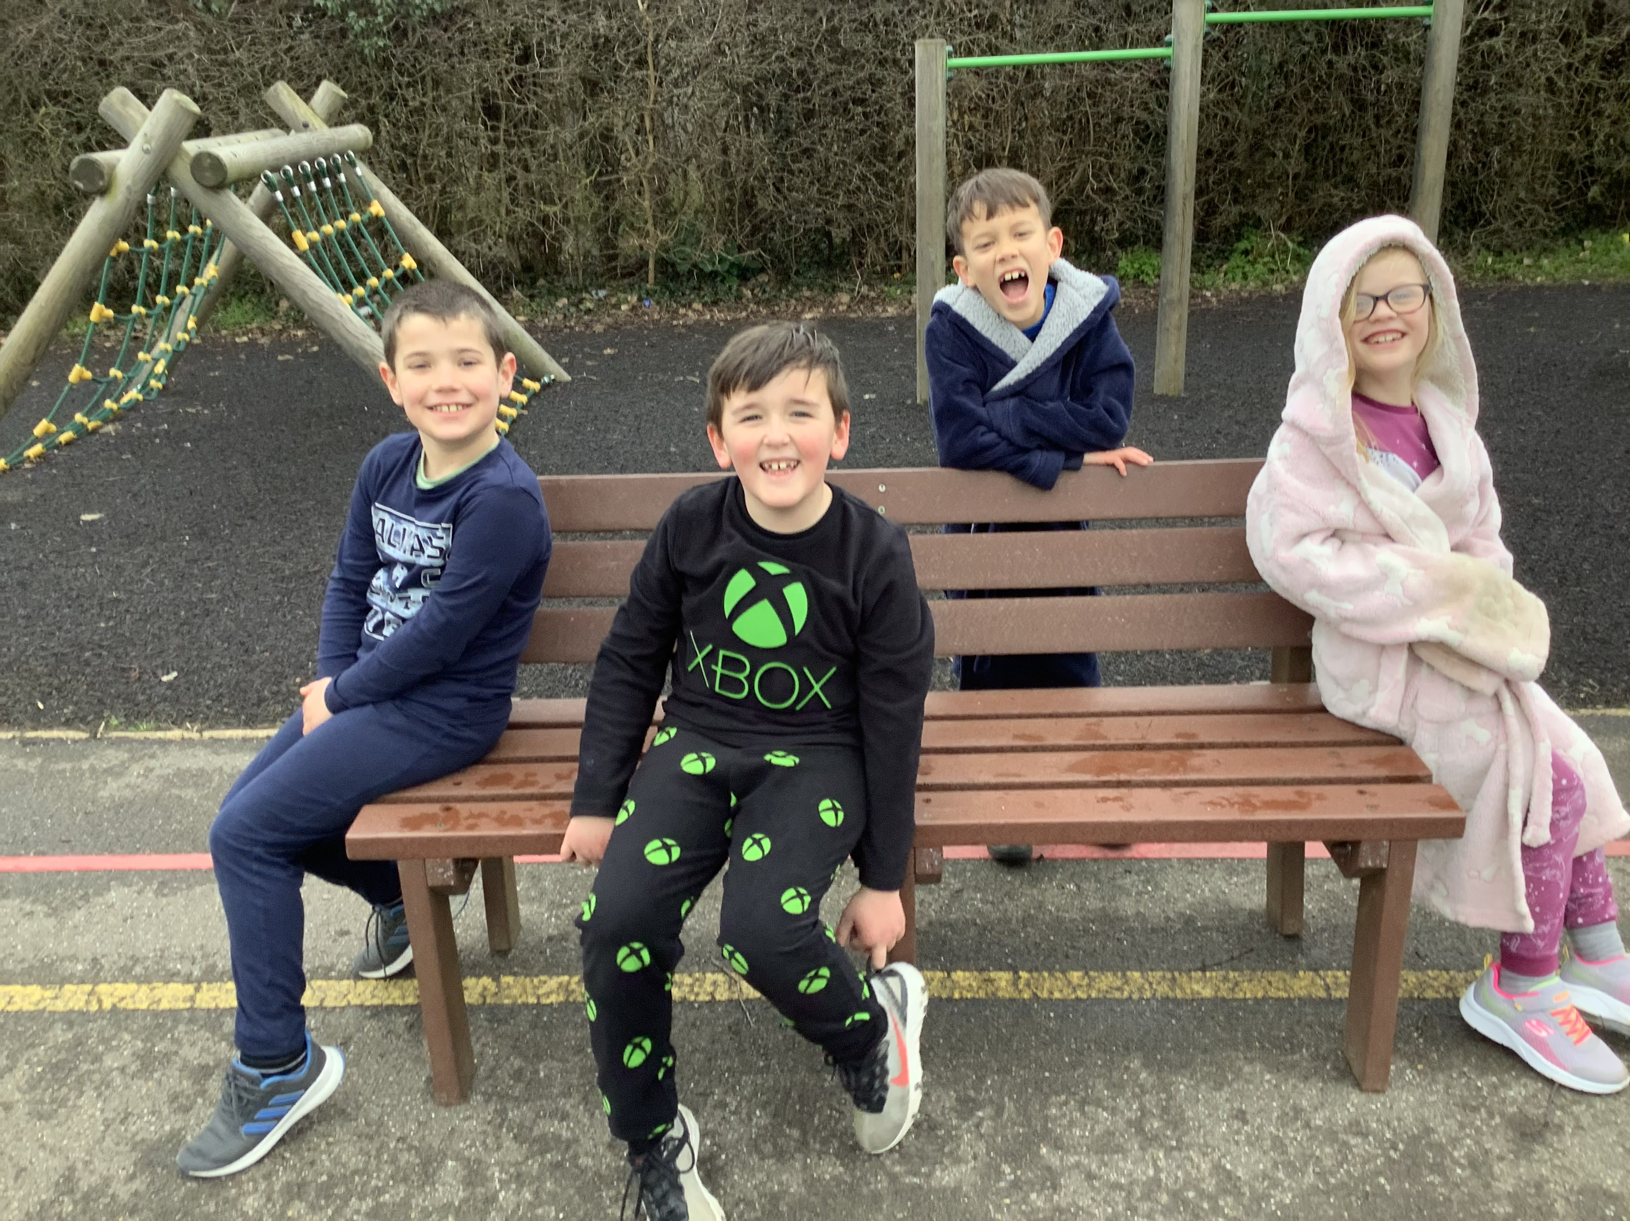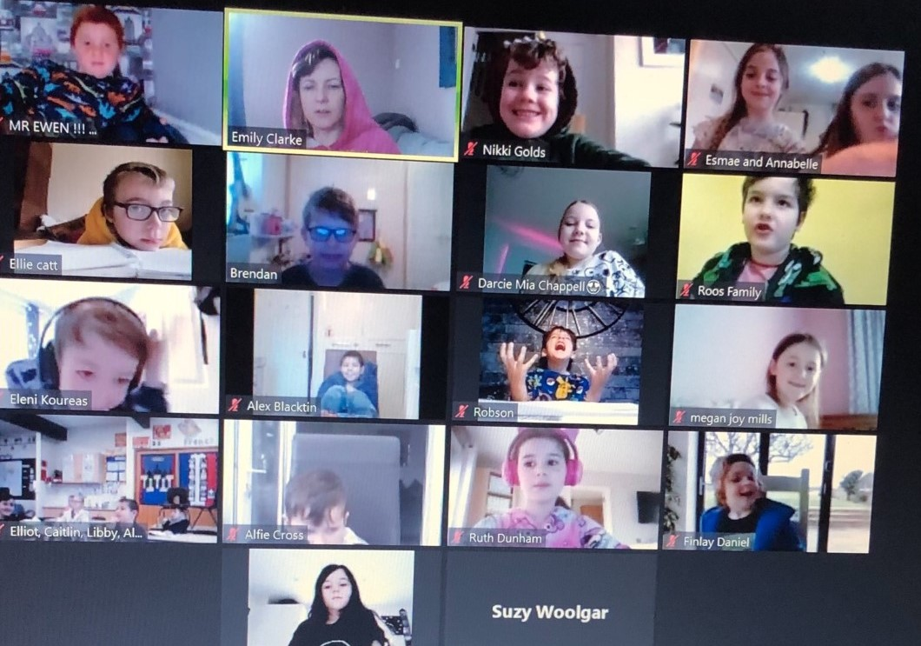
Year 5
Year 5
Year 5
Year 2

Stars of the Week
We know how hard the children are working both in school and at home during the lockdown and we have been really pleased with the work that is being returned to teachers. Every week, the teachers will choose 2 children from every class who have just amazed them with their participation, engagement and fantastic work. Teachers will be sending out Star of the week certificates and badges via our Marvellous Me and Tapestry platforms.
 | Stars of the week
Pre Sch | All of preschool have been stars throughout the lockdown. Many of you have been coming into school, on our live zoom lessons or have been sending in work you have been doing from home. We are amazingly proud of each and every one of you and looking forward to seeing you all next week in person. Well done Preschool.
Nur | Darcy - for her great number recognition and counting skills, as well as her confident recall of phonic sounds we have learnt so far. A great week all round. | Theo - for his confident return to nursery this week. He has tried really hard to listen and follow instructions and has joined in whole class teaching very well.
Rec | Rafe B - for always being here and always having something interesting to say! | Bella P - for her enthusiastic approach to home learning and home experiments!
Year 1 | Edward S - for showing a real love for reading and impressing his teachers with his confidence and fluency. | Poppy C - for being an outstanding role model in the classroom and having such a fantastic positive attitude.
Year 2 | Billy C- for completing his world book day challenge so well. | Felicity E for helping others when in school.
Year 3 | Darcie C - for her continued commitment to our online lessons and always trying her best. | Alfie C - For being a great role model to his class friends and his continued reliable presence in our online lessons.
Year 4 | Lucas - great attention and participation in live lessons | Ronnie - keeping focused on improving his handwriting and presentation throughout lockdown
Year 5W | Eva R - for her amazing contribution in zoom lessons and her wonderful costumes this week! | Flynn - for keeping our zoom alive! The last two weeks he has been so positive about other people’s contributions!
Year 5B | Sophie I- for maintaining an excellent level of work whilst at home. She constantly challenges herself and joins in eagerly on zoom. | Luke P- Luke has brilliantly balanced home learning and time in the bubble. He has been working to the best of his ability at all times.
Year 6 | Aaliyah – she has contributed with real enthusiasm during World Book Day this week. I have been very impressed with her preparations for her Harry Potter themed Afternoon Tea – I could tell she had put a lot of thought, care and effort into everything she created. Well done Aaliyah. | Willow – she has responded very creatively to activities during our remote learning and I have been so pleased with the way she has engaged. She has channelled her energy into special projects like World Book day and it has been good to see her enthusiasm. Well done Willow.

Parent Forum meeting

This Tuesday, I met virtually with our parent representatives for our second parent forum meeting this term. We discussed the changes that were made to remote learning following our last meeting on 25th January as well as discussing with them what the school priorities are once we are fully reopen next Monday. It is wonderful to have the parent representatives liaising with all parents so that they are able to share parental voice during these meetings on different aspects of school life. Our next meeting will be on 28th April and the agenda will be sent out to all the parent reps a week prior to the meeting. I welcome suggestions for the agenda from all parents and are happy for you to email your suggestions to admin@wattonatatsone.herts.sch.uk

Thank your child’s teacher
All of the school staff have worked incredibly hard during this lockdown and have adapted so well to remote teaching. If you or your child would like to personally thank the teachers or any of the staff for their support and help during the last few months, then please nominate them for a Thank a Teacher Award. The member of staff will receive a thank you card in the post which would mean so much to them. To get involved, please click on the link below
thankateacher.co.uk/forschools

Coming up next week – Science Week

The full reopening of the school next Monday coincides with Science week and we couldn’t think of a better way to welcome the children back than by taking part in this national annual event. Everyday next week, the children will be engaged in science – whether that be a science experiment, investigation, researching facts about scientists, reading books about science or getting outdoors to do practical science.
We will also be involving the whole school in ‘The Big Biscuit’ experiment where the children will be finding out what the best biscuits are for dunking! Lots of science will be taught whilst the children have lots of fun too.

Caught You Reading Competition

I hope that you have seen the Caught You Reading photo gallery that was saved to the website at the beginning of the week. We emailed you the link for you to view them also. The winners were chosen by an impartial judging panel and the winning entries were:
Early Years – Ethan L
Key Stage One – Cait S
Lower Key Stage Two – Oliver G
Upper Key Stage Two – Isabelle B
The Masked Reader
This week we organised another virtual event for the whole school community to get involved with during this period of lockdown – The Masked Reader.
Some members of staff disguised themselves whilst reading short excerpts from a story. The aim of the game was to identify who they all were by listening to their voices only (which weren’t disguised). The challenge will be open until next Wednesday (10th). Please send your completed answer sheets back to the class teachers. For those of you who have already attempted this challenge but are struggling to identify all the members of staff or remember everyone’s names, then here are the staff names (but not in order of appearance on the website!)

Mrs Higgins | Mrs Gugerly | Mrs Shortland | Mrs Roberts | Mrs Goodman
Mrs Hurley | Mrs Clarke | Mrs Etienne | Mrs Lee | Mrs Bunce
Mrs Gill | Mr Ring | Mrs Butler | Mrs Bell | Mrs Hawkins
Mrs Duston | Miss Oakley | Miss Dell | Mrs Clark (pre school) | Mrs Allman
Mrs Plunkett | Miss Ramirez

Lockdown birthdays
Wishing all the children who have celebrated their birthday during the half term holiday and this week a very happy birthday.
Taylor CH
5th March
Sam A
4th March

Monty K
3rd March

Lucy G
6th March
Freya H
1st March
Libby F
7th March

 | Pre school | Nursery | Reception | Year 1 | Year 2 | Year 3 | Year 4 | Year 5a | Year 5b | Year 6
Arrival | 8:45  11:45  12:30 | 8.50-9.00 | 8.30 – 8.40 | 8.40 – 8.50 | 8.30-8.40 | 8.40-8.50 | 8.30-8.40 | 8.50-9.00 | 8.50-9.00 | 8.40-8.50
Drop off point | Pre school | EYFS Gate | EYFS Gate | Main Gate | Main Gate | Main Gate | Dining Hall | Main Gate | Main Gate | Dining Hall
Entry to school | Preschool garden | Nursery garden | Reception garden | Corridor leading to KS1 classroom | Door by decking | Year 3 external door | Internal classroom door | Year 5a  external door | Year 5b  external door | Internal classroom door
Play time | Child-initiated learning time | Child-initiated learning time | Child-initiated learning time | 10.15-10.30  Zone 1 | 10.15-10.30  Zone 2 | 10.30-10.45  Zone 1 | 10.30-10.45  Zone 2 | 10.45-11.00  Zone 1 | 10.45-11.00  Zone 2 | 10.45-11.00  Zone 3
Lunch | 11:45-12:30 | 11:45-12:15 | 11:30 -12.30 | 12.00-1.00 | 12.00-1.00 | 12.00-1.00 | 12.30-1.30 | 12.30-1.30 | 12.30-1.30 | 12.30-1.30
Home time | 11:45/12:30/3:30 | 11:45/12:45  3.05-3.15 | 2.45-2.55 | 2.55-3.05 | 2.45-2.55 | 2.55-3.05 | 2.45 – 2.55 | 3.05-3.15 | 3.05.3.15 | 2.55-3.05
 | Preschool play ground | EYFS gate  Nursery play ground | EYFS gate  Reception  Play ground | Main gate  outside Year 1  door | Main gate  by the decking area | Main gate  zone 3 | Dining hall  door | Main gate  Zone 1 | Main gate  Zone 2 | Dining hall  door

Dates for your Diary


We are collecting items of school uniform to re gift back to the families at the school. If you have any unwanted uniform donations, then please leave them in the ‘drop off’ box located outside the main school office.
School jumpers or cardigans
School shoes
P.E Kits
Polo shirts and blouses
Grey trousers/shorts
Grey skirt/grey pinafore dress/green and white gingham dress
White socks/Grey socks/Grey or green tights
Black shoes

Many thanks for your support

March
8th – FULL SCHOOL REOPENING FOR ALL YEAR GROUPS
8th – 12th – Science week
18th – Zoom parent consultation meeting for new P.S.H.E/R.S.E curriculum
22nd – No Pens Day
26th – Early Years Virtual Farm Visits
26th – Last day of spring term

April
12th – INSET Day 3
13th – Children return to school
23rd – St. George’s day

May
3rd – 7th – Geography fieldwork week
21st – No Pens Day
31st – 4th June – Half term

June
7th – INSET Day 4
10th – Sports Day
17th – Reserve sports Day
30th – Book fair arrives for 1 week

July
2nd – Enterprise Day
5th – 9th – Assessment Week
12th – No Pens Day
14th – End of Year reports to parents/carers
21st – Last day of summer term
22nd – INSET Day

